Chesapeake Antique Boat and Marine Engine Show

May 2 and 3, 2009

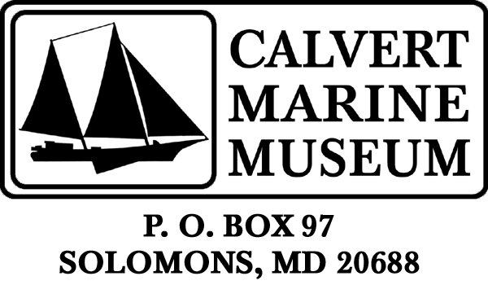

Display Panel

Calvert Marine Museum is offering to provide a display panel with pictures and text to illustrate the history of your boat or engine, or to show the stages of a restoration project.

We will take your photographs (maximum of six) and have them scanned and dry mounted on a 24”x30” gatorfoam board. You will also need to provide a title or heading and any text you want to include (150 words maximum, please). Please include your telephone number in case we have questions. All original photographs or other artwork will be returned. You can also send the text and images as a digital file (JPEG or TIFF) to phelpsjg@co.cal.md.us.

Text and photos will need to be received by April 9, 2009. After the show is over you get to keep the display! If you have any questions, please call Jean Phelps on (410) 326-2042, ext. 11 or email at above address.

(over)

